Create a dockerfile, docker-compose file which when executed must display your basic details in the website.

* First, we are going to create a new project in Visual Studio code

**Now, we are going to create a HTML file (index.html)**

It is a file that serves as a homepage for the website. It is an HTML file that defines the structure of a website.

HTML file:

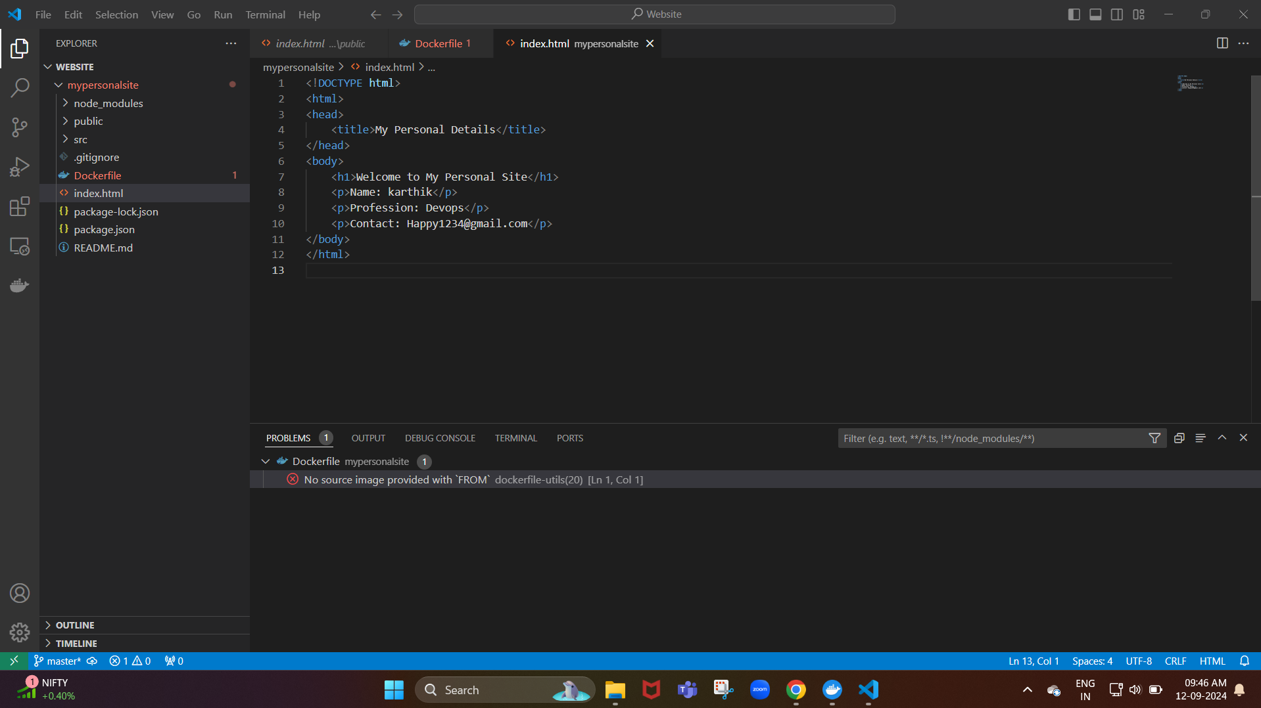

Now, the html file has been successfully created in the Visual Studio code

**Next, we are going to create a docker file**

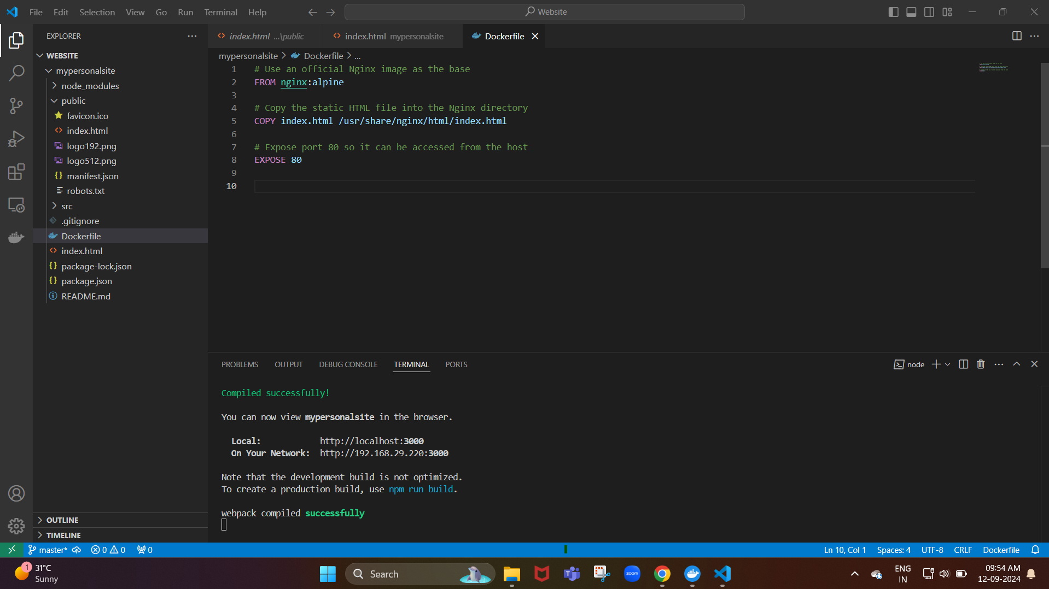

Now, we create a docker file here we will use the nginx image as as the base.

Next, we copy the static HTML file into the nginx directory

**Our next step is to create the docker-compose.yml**

It is a tool that helps you to share multi-container applications and with a single command we can we can spin everything.

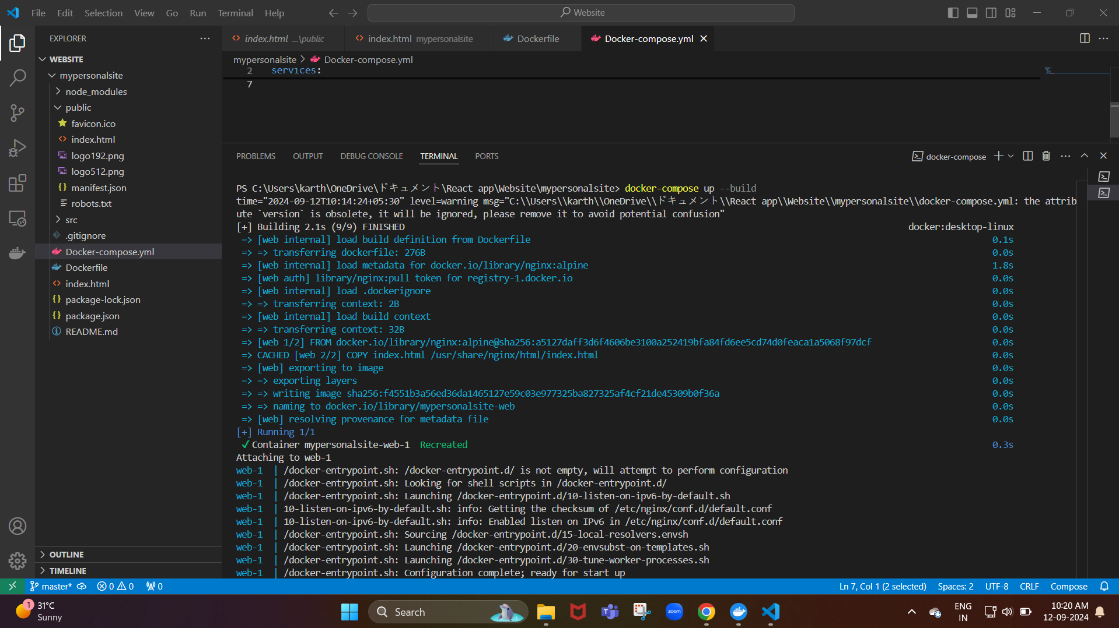

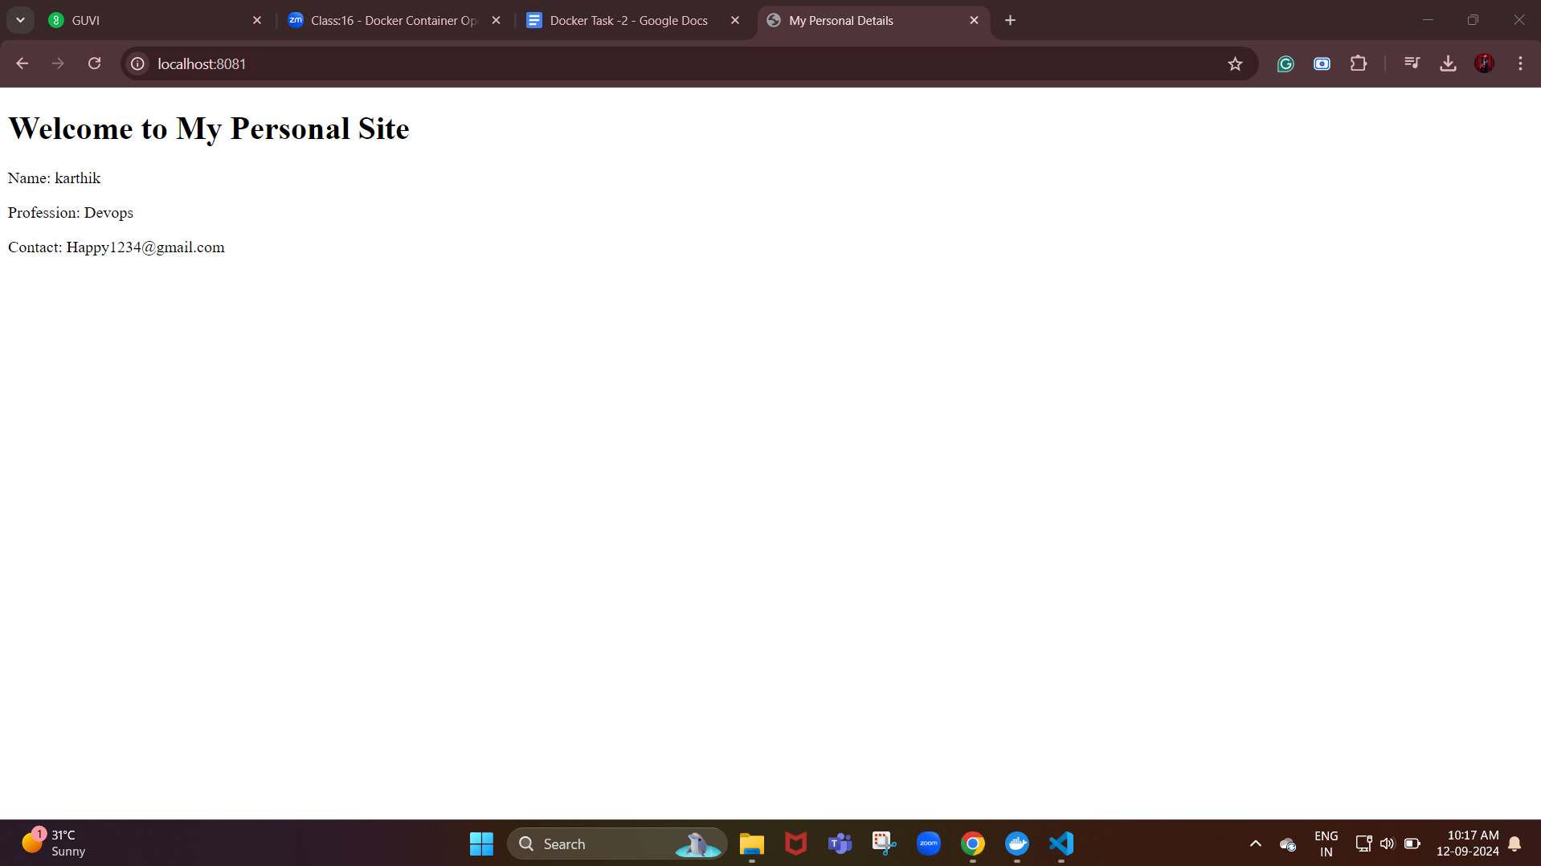

Now, we are able to see our personal website in the browser.

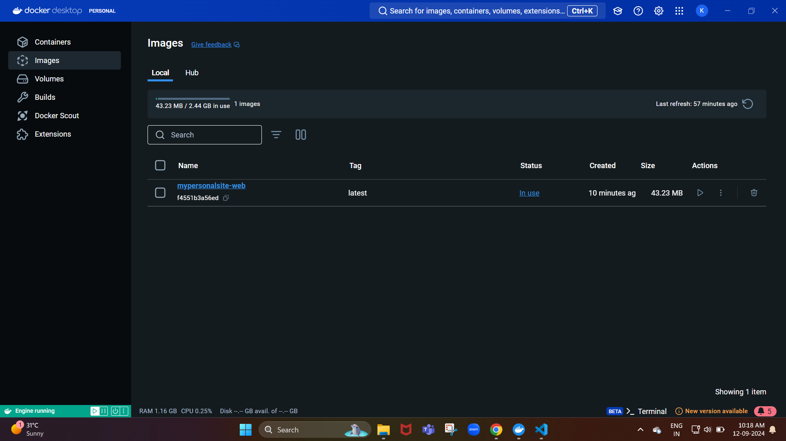

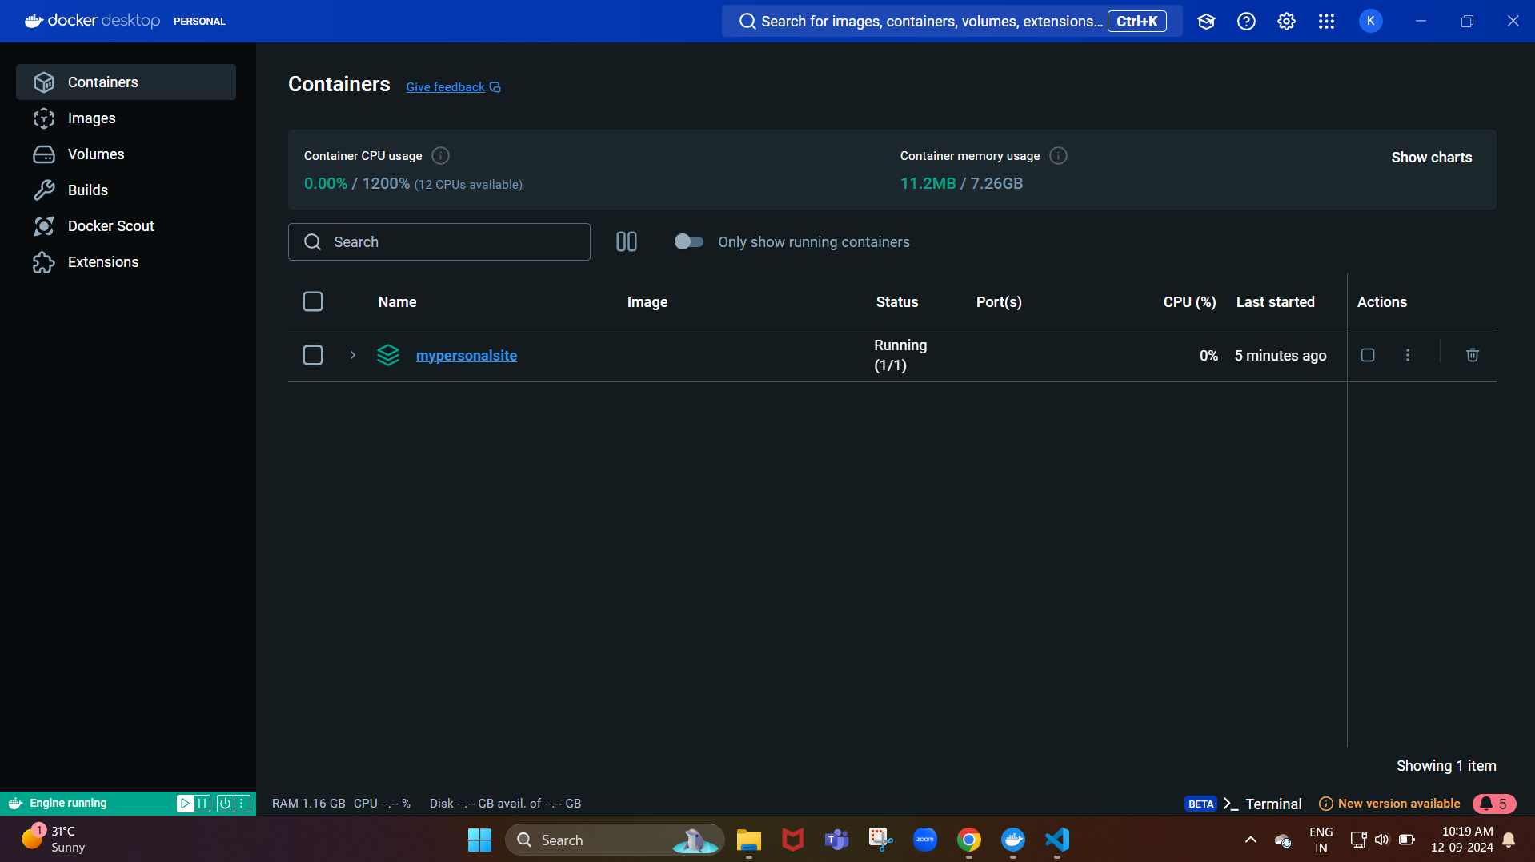

Result:

http://localhost:8081/